August 1st, 2010
Hi
Well, first of all, its ‘Happy Birthday’ to Leonie for Wednesday. Take your pick of birthday cards! (Actually, I have used these cars before but they are quite good.)

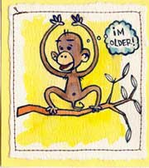


I only got two swims in this week due to weather and to the biopsy on Thursday. HK has been getting stormy weather with both thunderstorm and rain storm warnings at times. There are three colour-coded rain storm warnings, increasing in severity from amber to red to black. Why red comes before black, I and others are not sure, considering that red is supposed to be the colour for danger. The use of colours reminds me of the changes to the colours of traffic lights in China during the Cultural Revolution (1966-1976). Based on 'The East is Red', a favourite Mao slogan, the Red Guards ordered a change in the traffic lights with green to mean stop and red to mean go because red is the colour of the forward-moving revolution. I found an old 1966 article in TIME about this. Have a look at:
http://www.time.com/time/magazine/article/0,9171,842731,00.html
On Tuesday, I went to the pool for a swim only to find it was closed due to 'thunderstorms' which, in fact, at that time were not in HK but in China (I know, because I often check the thunderstorm/lightning strike map on the HK Observatory website). I persuaded them to open the pool which was good as quite a number of other people turned up for a swim. After I had finished however, the weather started to turn bad again and was very stormy in the evening.
On Wednesday evening, I had buffet dinner at the YMCA with a person from Pearson (publishers) who was visiting HK from Singapore. We had it even though the black rain storm warning was in effect.
By 7.30 am on Thursday, I was at Pok Oi hospital for a further nose biopsy - a long shape. (This is the hospital in Yuen Long which you may have seen from the bus to Sheung Shui.) It was performed by the same person I had seen at Tuen Mun hospital and was carried out to gauge the extent of the already confirmed sBCC in order to be sure it is all detected before the plastic surgery is done. I was there most of the morning. Quite nice as the hospital is very new. In the ante-room for the operation, arm chairs are provided for patients rather than just the usual plastic bucket chairs. I did no exercise that afternoon nor on Friday.
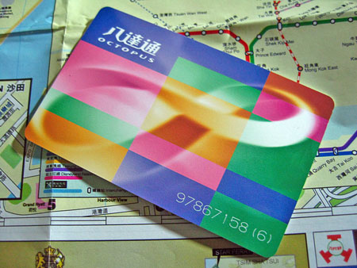
In HK, the Octopus card company is in trouble over the selling of personal data from card holders to various parties such as insurance companies who use it to contact people. This applies only to those many people who have personalised Octopus cards, which does not include me. I am not sure why people get personalised cards though there is a 'rewards' scheme which may entice people. Also, people can link their cards to their bank accounts to get automatic additions to the cards. However, these cards track all its uses, such as on transport, shopping, and even for opening doors at housing estates so gathers data that can be very useful. The MTR, which is a government corporation, is the major shareholder in the Octopus company and so the government itself is caught up in the scandal. It has also been revealed that some companies buying this data in turn sell it to others and also that some individual workers have copied the data when they leave and take it to other companies.
A note on demographics. In 30 years in HK, there are expected to be only 800 males for every 1000 females. The main reason for this is the increasing number of HK males who go to China to get brides then bring them back to HK. This will only exacerbate the gender imbalance in China where there are many more males that females.
Miscellaneous comments: This past week, bull fighting was banned in Barcelona and the rest of Catalonia. Similar decisions may eventually happen in the rest of Spain. More bad news regarding food supplements – there was a report that calcium supplements increase risk of heart attacks and don't help osteoporosis as much as they were thought to.
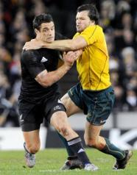
Yesterday, the ABs ripped Australia apart in a 49-28 victory in Melbourne. They scored seven tries to three, five of which were scored in the first half. However, there is a concern that the ABs are peaking too soon before next year's Rugby World Cup and that their impressive performances this year may come back to haunt them. This has happened in the past when they were all-conquering but collapsed in the world cups.
That’s about it for now.
Cheers

